**PRSQ-01-Medical Data History**

* **Change the column name attending_doctor_id to doctor_id of table admission to merge with table doctors.**

ALTER table admissions

RENAME COLUMN attending_doctor_id TO doctor_id;

**OUTPUT :-**

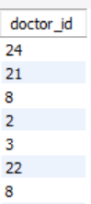

**1. Show first name, last name, and gender of patients who's gender is 'M'**

SELECT first_name,last_name,gender

FROM patients

WHERE gender='M';

**OUTPUT :-**

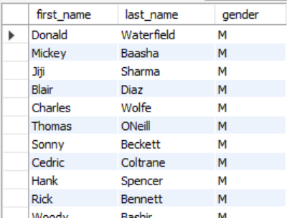

**2. Show first name and last name of patients who does not have allergies.**

SELECT first_name , last_name

FROM patients

WHERE allergies = ' ' ;

**OUTPUT :-**

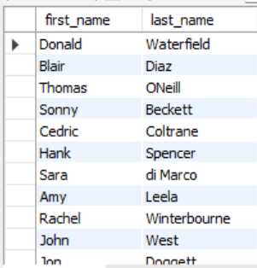

**3. Show first name of patients that start with the letter 'C'**

SELECT first_name

FROM patients

WHERE first_name

LIKE 'C%';

**OUTPUT :-**

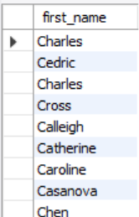

**4. Show first name and last name of patients that weight within the range of 100 to 120 (inclusive)**

SELECT first_name,last_name

FROM patients

WHERE weight

BETWEEN 100 AND 120;

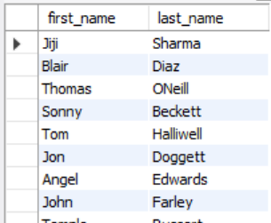 **OUTPUT :**

**5. Update the patients table for the allergies column. If the patient's allergies is null then replace it with 'NKA'**

UPDATE patients

SET allergies='NKA'

WHERE allergies = '' ;

**OUTPUT :-**

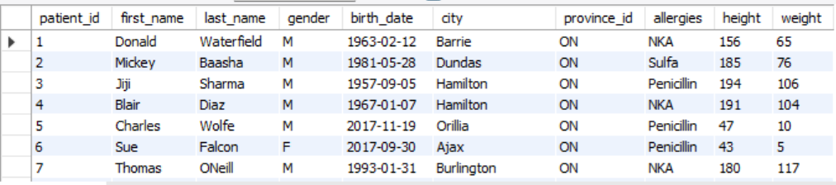

**6. Show first name and last name concatenated into one column to show their full name.**

SELECT concat (first_name,' ',last_name)

AS Full_Name

FROM patients;

**OUTPUT :-**



**7. Show first name, last name, and the full province name of each patient.**

SELECT

pa. first_name,

pa. last_name,

pr. Province_name

FROM patients pa

JOIN province_names pr

ON pa.province_id=pr.province_id;

**OUTPUT :-**

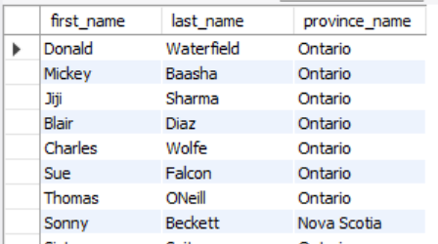

**8. Show how many patients have a birth_date with 2010 as the birth year.**

SELECT count(patient_id) AS Total_patients

FROM patients

WHERE YEAR(birth_date) = 2010;

**OUTPUT :-**

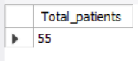

**9. Show the first_name, last_name, and height of the patient with the greatest height.**

SELECT first_name,last_name,height

FROM patients

WHERE height =

(SELECT MAX(height) FROM patients);

**OUTPUT :-**

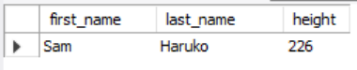

**10. Show all columns for patients who have one of the following patient_ids: 1,45,534,879,1000**

SELECT * FROM patients

WHERE patient_id IN(1,45,534,879,1000);

**OUTPUT :-**

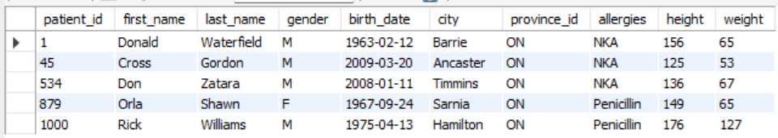

**11. Show the total number of admissions**

SELECT count(patient_id)

AS Total_admission

FROM admissions;

**OUTPUT :-**



**12. Show all the columns from admissions where the patient was admitted and discharged on the same day.**

SELECT * FROM admissions

WHERE admission_date = discharge_date;

**OUTPUT :-**

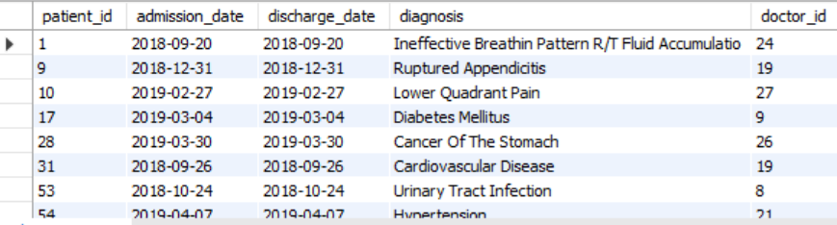

**13. Show the total number of admissions for patient_id 579.**

SELECT COUNT(*) AS Total_Admission

FROM admissions

WHERE patient_id=579;

**OUTPUT :-**



**14. Based on the cities that our patients live in, show unique cities that are in province_id 'NS'?**

SELECT city

FROM patients

WHERE province_id='NS'

GROUP BY city;

**OUTPUT :-**

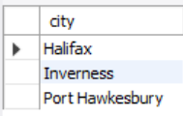

**15. Write a query to find the first_name, last name and birth date of patients who have height more than 160 and weight more than 70**

SELECT first_name, last_name, birth_date

FROM patients

WHERE height > 160 AND weight > 70;

**OUTPUT :-**

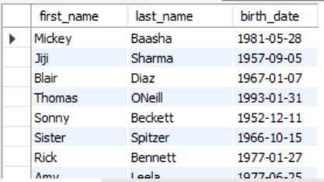

**16. Show unique birth years from patients and order them by ascending.**

SELECT YEAR(birth_date) AS Birth_Year

FROM patients

GROUP BY Birth_Year

ORDER BY Birth_Year ASC;

**OUTPUT :-**

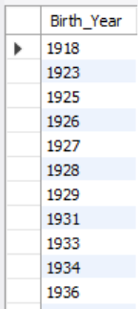

**17. Show unique first names from the patients table which only occurs once in the list.**

SELECT first_name

FROM patients

GROUP BY first_name

HAVING count(first_name)=1;

**OUTPUT :-**

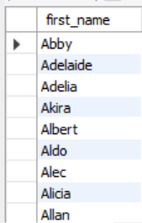

**18. Show patient_id and first_name from patients where their first_name start and ends with ‘s’ and is at least 6 characters long.**

SELECT patient_id,first_name

FROM patients

WHERE first_name

LIKE 's%s'

AND length(first_name) >= 6;

**OUTPUT :-**

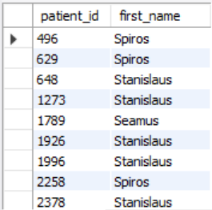

**19. Show patient_id, first_name, last_name from patients whos diagnosis is 'Dementia'. Primary diagnosis is stored in the admissions table.**

SELECT p.patient_id, p.first_name, p.last_name

FROM patients p

JOIN admissions a

ON p.patient_id = a.patient_id

WHERE diagnosis = 'Dementia' ;

**OUTPUT :-**

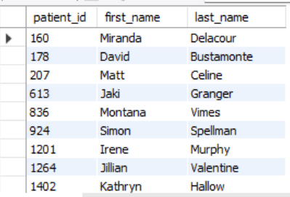

**20. Display every patient’s first_name. Order the list by the length of each name and then by alphabetically.**

SELECT first_name

FROM patients

ORDER BY LENGTH(first_name),first_name ;

**OUTPUT :-**

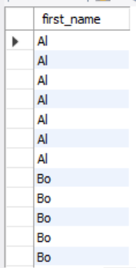

**21. Show the total amount of male patients and the total amount of female patients in the patients table. Display the two results in the same row.**

**AND**

**22. Show the total amount of male patients and the total amount of female patients in the patients table. Display the two results in the same row.**

SELECT

COUNT(CASE WHEN gender = 'M' THEN 1 END) AS male_patients, COUNT(CASE WHEN gender = 'F' THEN 1 END) AS female_patients

FROM patients;

**OUTPUT :-**

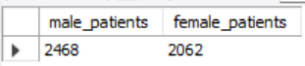

**23. Show patient_id, diagnosis from admissions. Find patients admitted multiple times for the same diagnosis.**

SELECT patient_id,diagnosis

FROM admissions

GROUP BY patient_id,diagnosis

HAVING count(*)>1;

**OUTPUT :-**

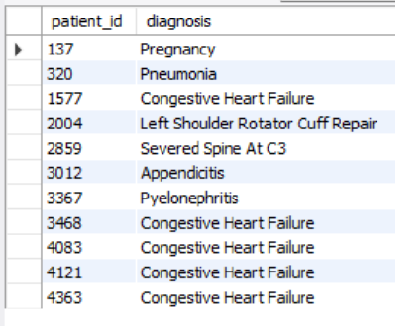

**24. Show the city and the total number of patients in the city. Order from most to least patients and then by city name ascending.**

SELECT city, COUNT(*) AS Total_patients

FROM patients

GROUP BY city

ORDER BY Total_patients DESC,city ASC ;

**OUTPUT :-**

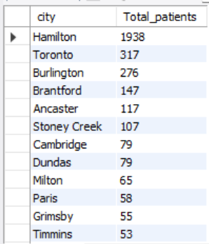

**25. Show first name, last name and role of every person that is either patient or doctor. The roles are either "Patient" or "Doctor"**

SELECT first_name,last_name,'Patient' AS role

FROM patients

UNION

SELECT first_name,last_name,'Doctor' AS role

FROM doctors;

**OUTPUT :-**

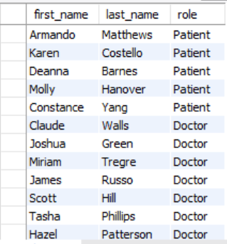

**26. Show all allergies ordered by popularity. Remove NULL values from query.**

SELECT allergies,COUNT(allergies) AS Total_Patients

FROM patients WHERE allergies != 'NKA'

GROUP BY allergies

ORDER BY Total_Patients DESC;

**OUTPUT :-**

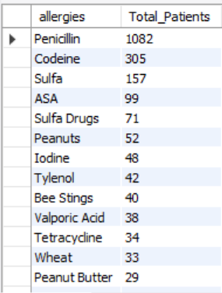

**27. Show all patient's first_name, last_name, and birth_date who were born in the 1970s decade. Sort the list starting from the earliest birth_date.**

**SELECT first_name, last_name, birth_date**

**FROM patients**

**WHERE YEAR(birth_date)**

**BETWEEN 1970 AND 1979**

**ORDER BY birth_date;**

**OUTPUT :-**

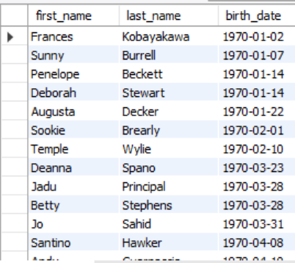

**28. We want to display each patient’s full name in a single column. Their last_name in all upper letters must appear first, then first_name in all lower case letters. Separate the last_name and first_name with a comma. Order the list by the first_name in decending order EX: SMITH,jane**

SELECT CONCAT(UPPER(last_name),",",LOWER(first_name))

AS Full_Name

FROM patients

ORDER BY first_name DESC**;**

**OUTPUT :-**

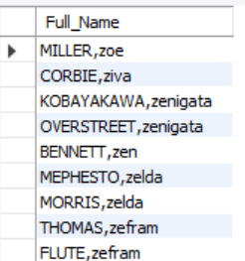

**29. Show the province_id(s), sum of height; where the total sum of its patient’s height is greater than or equal to 7,000.**

SELECT province_id, SUM(height) AS sum_of_height

FROM patients

GROUP BY province_id

HAVING sum_of_height >= 7000;

**OUTPUT :-**

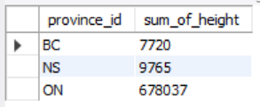

**30. Show the difference between the largest weight and smallest weight for patients with the last name 'Maroni'.**

SELECT max(weight) - min(weight)

AS difference

FROM patients

WHERE last_name = 'Maroni' ;

**OUTPUT :-**

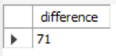

**31. Show all of the days of the month (1-31) and how many admission_dates occurred on that day. Sort by the day with most admissions to least admissions.**

SELECT DAY(admission_date) AS Day_Of_month,

COUNT(*) AS Total_Admission

FROM admissions

GROUP BY Day_Of_month

ORDER BY Total_Admission DESC;

**OUTPUT :-**

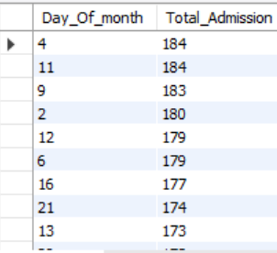

**32. Show all of the patients grouped into weight groups. Show the total amount of patients in each weight group. Order the list by the weight group decending. e.g. if they weight 100 to 109 they are placed in the 100 weight group, 110-119 = 110 weight group, etc.**

SELECT (weight DIV 10 ) * 10 as Weight_group ,

count(*) AS total_patients

from patients

WHERE weight IS NOT NULL

GROUP BY Weight_group

ORDER BY Weight_group DESC;

**OUTPUT :-**

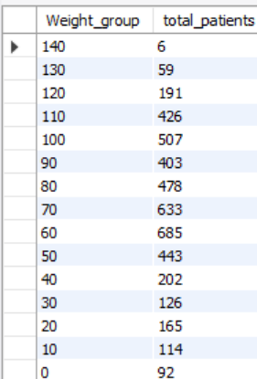

**33. Show patient_id, weight, height, isObese from the patients table. Display isObese as a boolean 0 or 1. Obese is defined as weight(kg)/(height(m). Weight is in units kg. Height is in units cm.**

SELECT patient_id,height,weight,

CASE WHEN (weight / POWER(height/100,2)) >= 30

THEN 1 ELSE 0

END AS Isobese

FROM patients ;

**OUTPUT :-**

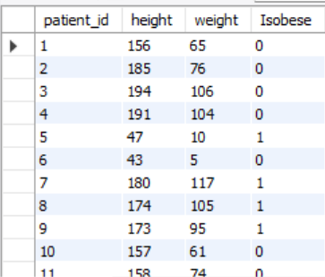

**34. Show patient_id, first_name, last_name, and attending doctor's specialty. Show only the patients who has a diagnosis as 'Epilepsy' and the doctor's first name is 'Lisa'. Check patients, admissions, and doctors tables for required information.**

SELECT P.patient_id, P.first_name, P.last_name, D.specialty

FROM patients P

JOIN admissions A ON P.patient_id = A.patient_id

JOIN doctors D ON A.doctor_id = D.doctor_id

WHERE A.diagnosis='Epilepsy' and D.first_name = 'Lisa' **;**

**OUTPUT :-**

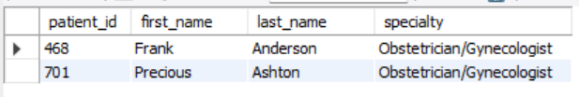

**35. All patients who have gone through admissions, can see their medical documents on our site. Those patients are given a temporary password after their first admission. Show the patient_id and temp_password.**

**The password must be the following, in order:**

**- patient_id**

**- the numerical length of patient's last_name**

**- year of patient's birth_date**

SELECT patient_id,CONCAT(patient_id,LENGTH(last_name),YEAR(birth_date))

AS temprory_posword

FROM patients;

**OUTPUT :-**

